COS225 Chapter 23 – Quick Sort and Radix Sort

Quicksort is an efficient sort for large sets of randomly dispersed data. This algorithm selects a pivot value and then rearranges all numbers in the array so that everything to the left of the pivot is less than everything to the right of the pivot. It then calls itself recursively on each piece.

If (size of partition is <= 1) return
Partition array around pivot so all items on left side <= pivot and all items on right side > pivot
Call quicksort on left partition
Call quicksort on right partition

The technique for partitioning the array starts by selecting one of the values to be the pivot. This might be the first, middle, last, or random element in the group. The partitioning method shown below uses a left pivot.

private static <T extends Comparable<T>> int partition (T[ ] data, int first, int last)
{
int left = first;
int right = last;
T temp;
T pivot = data[first];
while (left < right)
{ while (data[right].compareTo(pivot)>0) // search right for item <= pivot
right--;
while (left < right && data[left].compareTo(pivot)<=0) // search left for item > pivot
left++;
if (left < right) // swap elements
swap (data, left, right);
}
data[first] = data[right]; // place pivot into final position
data[right] = pivot;
return right;
}
Initially:

40 | 25 | 45 | 90 | 20 | 10 | 5 | 25 | 60 | 15
0 1 2 3 4 5 6 7 8 9
first last
left right
pivot = array[left] = 40

left and right yield:
40 | 25 | 45 | 90 | 20 | 10 | 5 | 25 | 60 | 15
0 1 2 3 4 5 6 7 8 9
first left last
right
The values are swapped:
40 | 25 | 15 | 90 | 20 | 10 | 5 | 25 | 60 | 45
0 1 2 3 4 5 6 7 8 9
first left last
right
Since left < right repeat. The second scan for left and right yields:
40 | 25 | 15 | 90 | 20 | 10 | 5 | 25 | 60 | 45
0 1 2 3 4 5 6 7 8 9
first left right last

The values are swapped:
40 | 25 | 15 | 25 | 20 | 10 | 5 | 90 | 60 | 45
0 1 2 3 4 5 6 7 8 9
first left right last

Since left < right repeat. Left ascends until it hits right and stops.
40 | 25 | 15 | 25 | 20 | 10 | 5 | 90 | 60 | 45
0 1 2 3 4 5 6 7 8 9
first right last
left

Since left == right, do not swap. The loop terminates. The final line swaps the pivot 40 into its final sorted position at index 6. It will never be considered again. quicksort will be called on the partitions [0 .. 5] and [7 .. 9] Notice all values to the left of 40 are smaller and all values to the right are larger.

5 | 25 | 15 | 25 | 20 | 10 | 40 | 90 | 60 | 45
0 1 2 3 4 5 6 7 8 9
first right last
left
*40 is set*

public static <T extends Comparable<T>> void quickSort (T data[ ], int first, int last)
{
int pos; // final position of pivot
if (first < last) // list has more than one element
{ pos = partition (data, first, last); // partition around pivot
quickSort (data, first, pos - 1); // sort left sublist
quickSort (data, pos + 1, last); // sort right sublist
}
}

The performance of quickSort depends on the pattern of the data and the choice of the pivot value. Mathematical analysis has shown that the average case yields a run-time of O(n log n). The number of partitions created is determined by the array size and is thus O(n). This corresponds to the outer loop of the selection sort.

In the selection sort the inner loop is repeated n-1, n-2, n-3, n-4, … times as the unsorted part of the array gets smaller and smaller. Unfortunately, this still leads to a linear algorithm O(n) on the inner loop.

In quickSort, if the pivot does a good job and splits the array into 2 equal pieces, the partition sizes decrease quickly to n/2, n/4, n/8, n/16, ….. This leads to a logarithmic algorithm O(log n)

The overall run-time of O(n*log n). For large n, the run-time difference is much better when compared to an O(n²) sort.

n Time O(n²) O(n log n)
10000 1 sec
80000 8² = 64 sec 8 * log 8 = 8 * 3 = 24 sec
160000 16² = 256 sec 16 * log 16 = 16 * 4 = 64 sec

Most sort algorithms in libraries are variations/hybrids of quicksort or merge sort. Merge sort is listed in the textbook for your reference. The algorithm divides the array into two halves and applies mergesort on each half, recursively. After the two halves are sorted, they are merged back together.

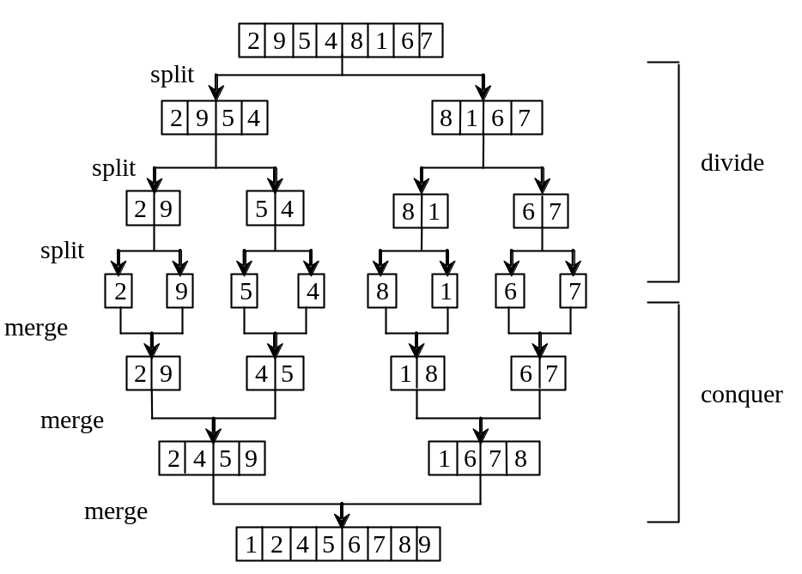

Radix Sort:
This sort sorts integer keys with the use of queues to hold pieces of the original list. For integer data (or composite data with an integer key) , radix sort establishes 10 queues, one for each digit. On the first pass, it inserts each item into the correct queue by its value in the units place and then writes the queues back into the original array. On the second pass, it inserts each key into the correct queue by its value in the tens place and then writes the queues back into the original array. The number of passes is controlled by the highest power of 10 in the data.

49 | 24 | 42 | 54 | 69 | 29 | 43 | 64 | 47

After the first pass:
Queue:
0
1
2 42
3 43
4 24 54 64
5
6
7 47
8
9 49 69 29

42 | 43 | 24 | 54 | 64 | 47 | 49 | 69 | 29

After the second pass:

Queue:
0
1
2 24 29
3
4 42 43 47 49
5 54
6 64 69
7
8
9

24 | 29 | 42 | 43 | 47 | 49 | 54 | 64 | 69

Analysis of radix sort:

The power of radix sort is its slow run-time growth. The outer loop iterates a constant number of time from the units place to the largest power of 10 in the data. In this example the outer loop only needed to make 2 passes through the original array. Since this loop is independent of the size of the data set it is constant time O(1).

The inner loop needs to extract a digit from the number and insert the number in the correct queue. Finally, it needs to rewrite into the array from the queues. The run-time from this combination of steps is O(n) for a final optimal run-time of O(n).

The problem with radix sort is its use of additional memory and the housekeeping involved in maintaining the queues. When sorting integer keys there must be 10 queues. Each queue must be able to accommodate the same size as the original array to handle the special case where all the data ends up in the same queue. Remember that the faster sort methods are only needed when the data set is large.

public static void radixSort (Integer data[ ])
{
Queue<Integer> [ ] digitQueues = (LinkedList<Integer>[ ]) (new LinkedList [10]);
// array of 10 queue references
for (int k = 0; k < 10; k++) // create 10 queues
digitQueues[k] = new LinkedList<Integer> ( );
int digit; // digit (0 .. 9)

for (int k = 0; k < data.length; k++) // fill queues by units place
{ digit = data[k] % 10; // get units place digit
digitQueues[digit].add(data[k]); // enqueue to that digit's queue
}
int i = 0;
for (int q = 0; q < 10; q++) // loop through queues 1 - 10
while (!digitQueues[q].isEmpty()) // dequeue value and insert back
{ data[i] = digitQueues[q].peek();
digitQueues[q].remove();
i++;
}

for (int k = 0; k < data.length; k++) // fill queues by tens place
{ digit = data[k] / 10; // get tens place digit
digitQueues[digit].add(data[k]);
}
i = 0;
for (int q = 0; q < 10; q++) // loop through queues 1 - 10
while (!digitQueues[q].isEmpty()) // dequeue value and insert back
{ data[i] = digitQueues[q].peek();
digitQueues[q].remove( );
i++;
}
}

